Telstra Lite 3

Type of device: Mobile
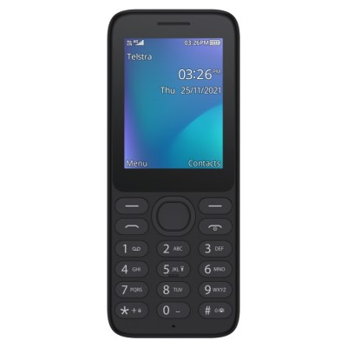

Actual Display Size : 2.4 inches
Button Type : Physical Keypad
Network Capability : 3G,4G
Year of Release : 2022
Average Price : $59 as of 30 11 2022
Other : Thread X

Accessibility Features:

Cognitive
Simple Instructions

Hearing Impairment and Deaf
- Bluetooth or Wi-Fi
- Text Messaging/SMS
Vibrating Alerts - Adjustable

Vision
- Bluetooth or Wi-Fi
- Key Marker – Raised '5'
- Key Numbers - Standard Layout
Key Press - Vibration or Click

Speech
- Bluetooth or Wi-Fi
- Messaging Options - IM
Messaging Options - MMS

Physical
- Bluetooth or Wi-Fi
- Headset - plug connected
- Physical Dialling Keys
Speaker-phone option

How and where to get it from?
You can buy this phone from Telstra, Kmart, Australia Post, and other retailers.

More information is available on:
Telstra Lite 3 webpage

